Date | 28.09.2026
Team ID | SWTID-2026-6482
Project Name | Auto Ticket Classification using Flow Designer

Project Planning Phase –IV

2) User Acceptance Testing (UAT)

Objective of User Acceptance Testing
User Acceptance Testing ensures that the solution meets business requirements and is accepted by end users (Students, Teachers, IT Staff). As per your PDF Phase 4 and Phase 5, solution must be stable, reusable, and ready for demonstration.

UAT Scenarios - Test Scenarios
UAT ID | User Role | Test Action | Input (Short Description) | Expected Output | User Acceptance
UAT-01 | Student | Creates WiFi ticket | WiFi not working in library | Category=Network, Subcategory=Wi-Fi, Email sent | Accepted - Student confirms auto classification correct
UAT-02 | Teacher | Creates Projector ticket | Projector not turning on in class 101 | Category=Hardware, Subcategory=Projector, Email sent | Accepted - Teacher confirms
UAT-03 | Student | Creates Password ticket | Forgot password cannot login to portal | Category=Access, Subcategory=Forgot Password | Accepted
UAT-04 | Teacher | Creates Slow Computer ticket | My computer is very slow and hanging | Category=Performance, Subcategory=Slow Computer | Accepted
UAT-05 | IT Agent (L1) | Verifies routing | Open assigned tickets | Tickets correctly categorized, no manual effort needed | Accepted - IT Staff confirms manual effort reduced by 80%
UAT-06 | IT Admin | Verifies Email & Update Set | Check Emails table + Local Update Sets -> Export to XML | Email preview correct, Update Set complete and exportable | Accepted - Ready for deployment

UAT Testing Diagram
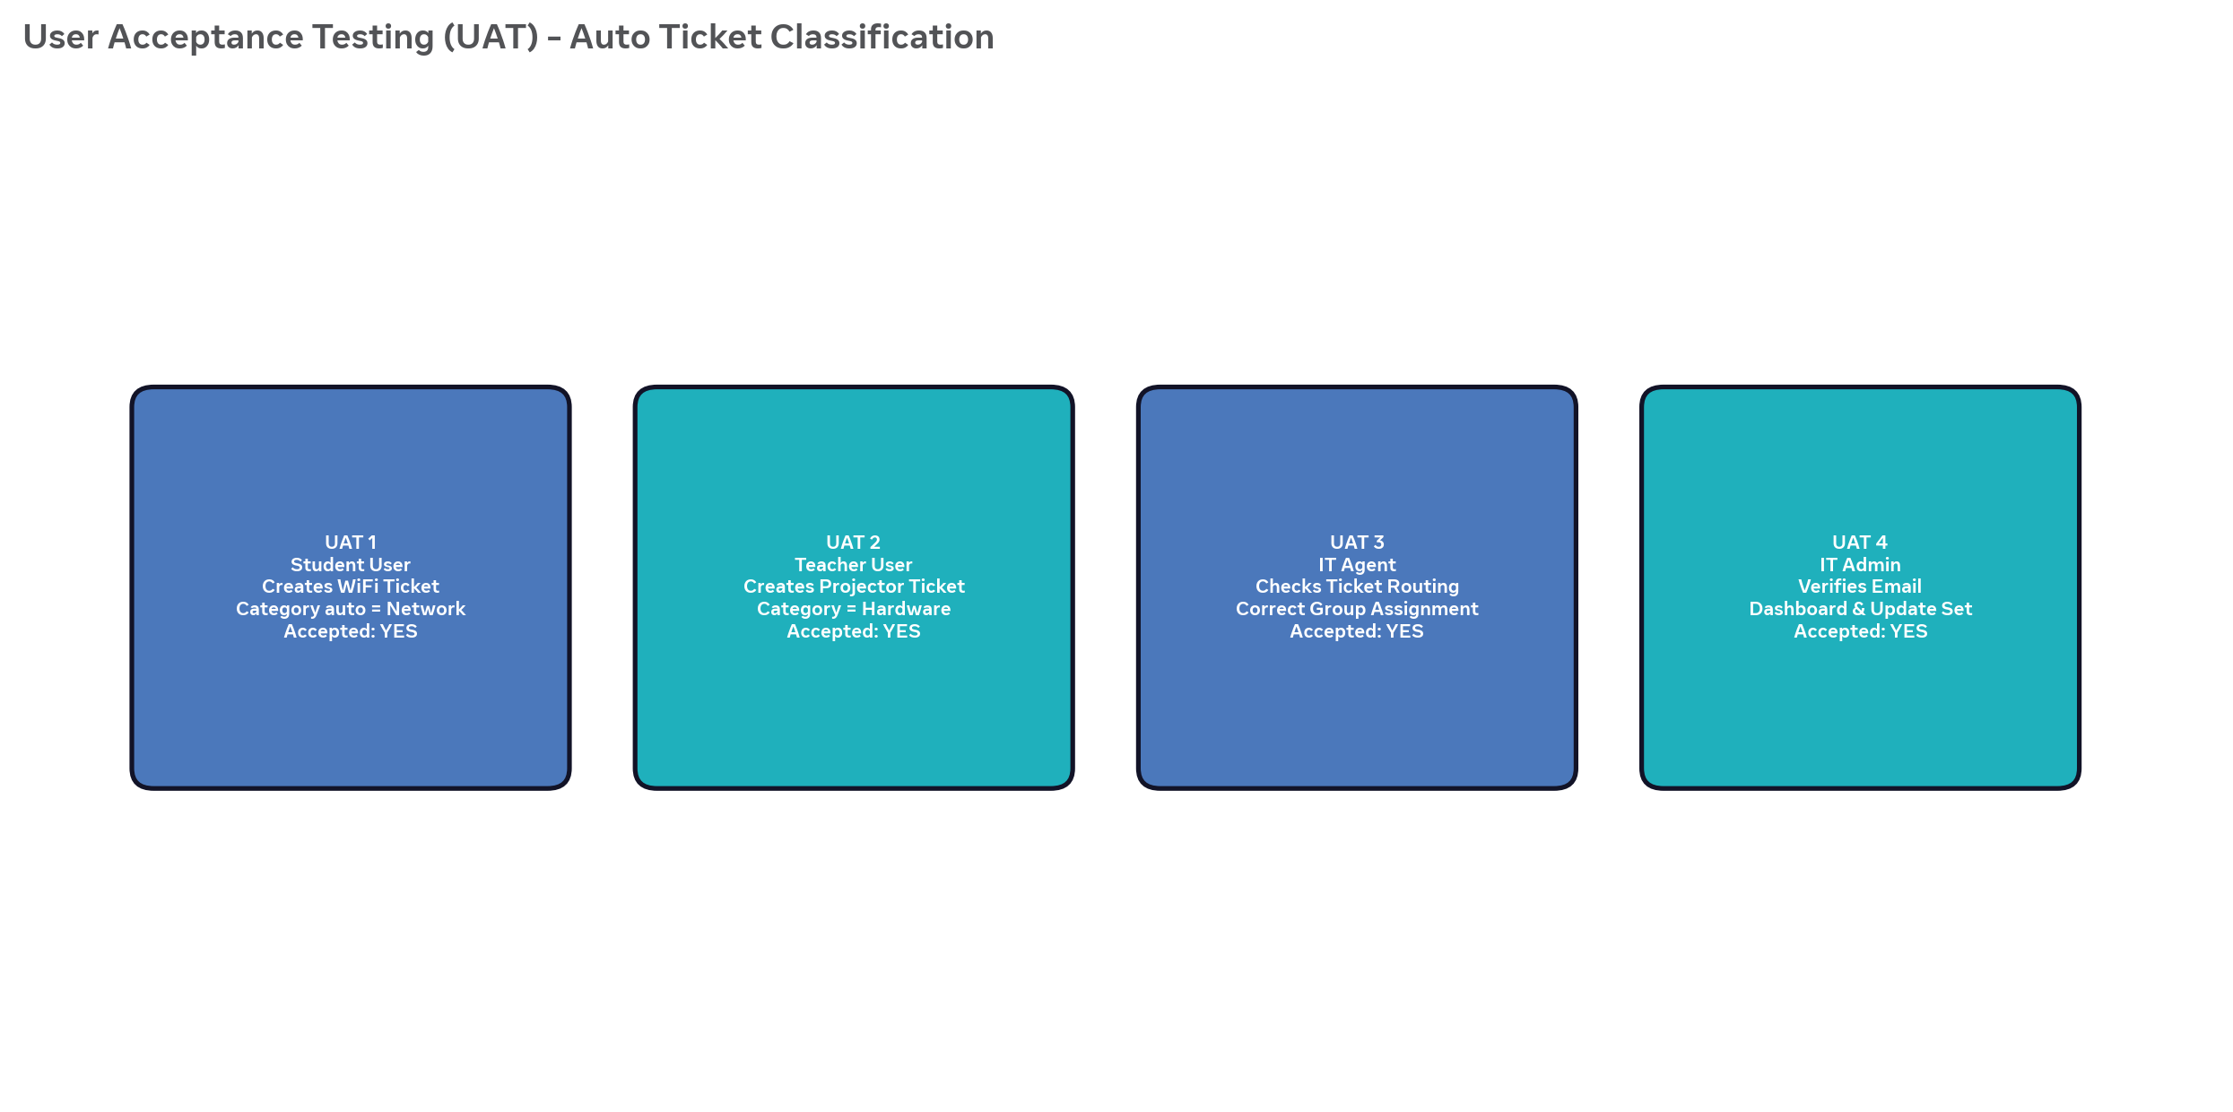UAT Sign-off Checklist (As per PDF Conclusion)
• End-to-end automation works: Ticket creation -> Auto Classification -> Email -> Closed
• Consistent classification, eliminates human error
• No-code solution, easy to maintain, scalable
• Data accuracy: Mandatory fields, auto-number, reference fields validated
• Security: Only authorized users can access/modify ticket data
• Deployment: Update Set exported to XML and shareable via WhatsApp/Mail
• Documentation complete for future reference
Overall, solution demonstrates ServiceNow can be effectively used to build scalable, maintainable, user-friendly automation without complex scripting.

Navigation for UAT
• For Student/Teacher UAT: Go to Incident WorkFlow Table -> New -> Enter Caller + Short Description -> Save -> Reload Form -> Verify Category/Subcategory auto-filled
• For Email UAT: All -> System Logs -> Emails -> Search Subject -> Preview mail
• For IT Admin UAT: All -> Local Update Sets -> Open Project Update Set -> State In progress to Complete -> Save -> Export to XML -> Download
• Get sign-off from users after successful verification

